**Documentation for fresh sales suite**

**Overview:**

**Customer relationship management** (**CRM**) is a process in which a business or other organization administers its interactions with customers, typically using data analysis to study large amounts of information.

**Freshsales suite CRM:**

**An all-in-one CRM with a unified sales and marketing platform**

Freshsales Suite is cloud CRM software that breaks organizational silos across sales, marketing, and support, allowing businesses to connect with customers across all touchpoints in one system.

|  |  |  |
| --- | --- | --- |
| **Freshsales CRM:** | **Freshsales suite CRM** | **Freshsales marketer** |
| The freshworks CRM is an AI powered customer relationship management solution that combines the power of sales automation, marketing automation, chat and telephone. | Freshsales Suite is a unified solution for all sales and marketing needs. To put it simply, it is Sales CRM + Marketing Automation + Cloud Telephony + chat + Machine learning in one platform. | Freshmarketer enables you to **capture visitors, track their journey on your website, and engage with them more contextually using:** **Web forms**: Code-free web forms allow you to capture the details of high-intent website visitors using discounts, offers, or other promotions. |
| All in one solution, we built everything your sales and marketing teams need so you can attract quality leads engage across multiple channels and touch points close deals faster and nurture customer relationships. | With a highly intuitive UI and a robust feature set, attract prospective leads and nurture relationships throughout the customer lifecycle. | Freshmarketer helps marketing teams deliver more personalized customer experiences at  Every touchpoint across their lifecycle. Get insights into your audience’s behavior and  engagement to create unique buyer experiences. You can automate conversations with  website visitors using AI chatbots, segment contacts into lists, create targeted  personalized email campaigns using journeys, and nurture customers to keep coming  back. |
| With freshworks CRM create a single source of truth for your customer information across sales and marketing teams as they work together to provide one seamless customer experience with freshworks CRM. | Get more contexts into prospects, have meaningful conversations with leads, nurture customers for upsell and cross-sell opportunities, and never miss a chance to close more deals. | With powerful campaigns analytics in Freshmarketer, you gain insights on opens, clicks,  and responses to improve engagement and generate quality leads for sales teams. Also,  the self-serve landing page builder and native CRO help to accelerate lead generation and  Conversion. |

**How can Freshsales Suite help you grow your business?**

**Nurture relationships and grow revenue with a single customer view -** Deliver seamless engagement across channels with a 360° view of the customer. Unify sales and marketing teams to deliver customer delight.

**Close deals faster by sending the right message at the right time -** Sales and marketing can work together to deliver personalized customer experiences. Understand customer intent and send the right message to close deals faster.

**Reduce IT complexity & cost with a comprehensive solution -** Keep teams happy with a single, all-in-one solution that is affordable, easy to implement, and easier to use. Increase adoption, reduce costs and boost morale.

**Trusted by businesses worldwide**

Sify

Cadence Health

Blue Nile

Dyson

Unzo

PharmEasy

Klarna

MTR

**CRM Dashboard:**

In this dashboard, we can see the list of activity, analytics, sales dashboard, and marketing dashboard.

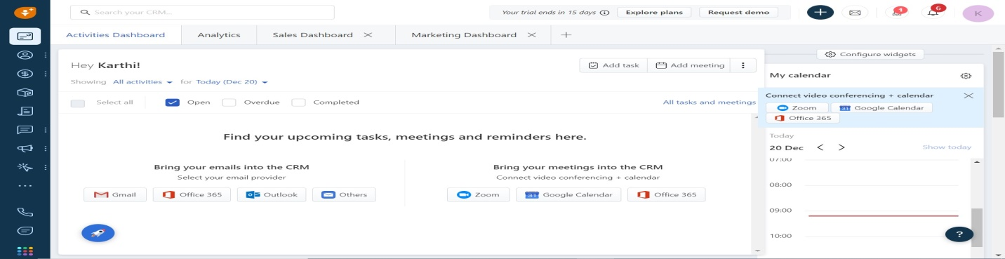

**Analytics**

In this activity dashboard, we can see the list of reports to be generated here. If we want to select particular reports, we have to click ‘All report’ to select desired report type.

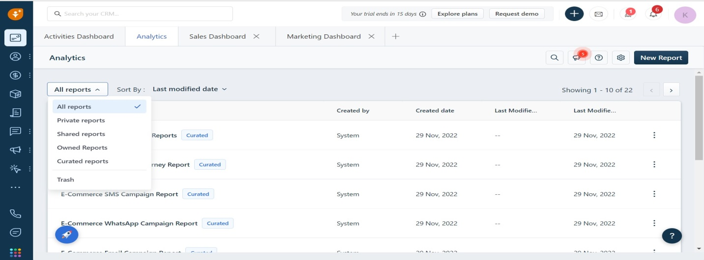

**Sales dashboard**

In this sales dashboard, to shows the graph chart for contacts create, contacts by owner, open pipeline, deals closed over time, stage-wise forecast and quota vs achievement

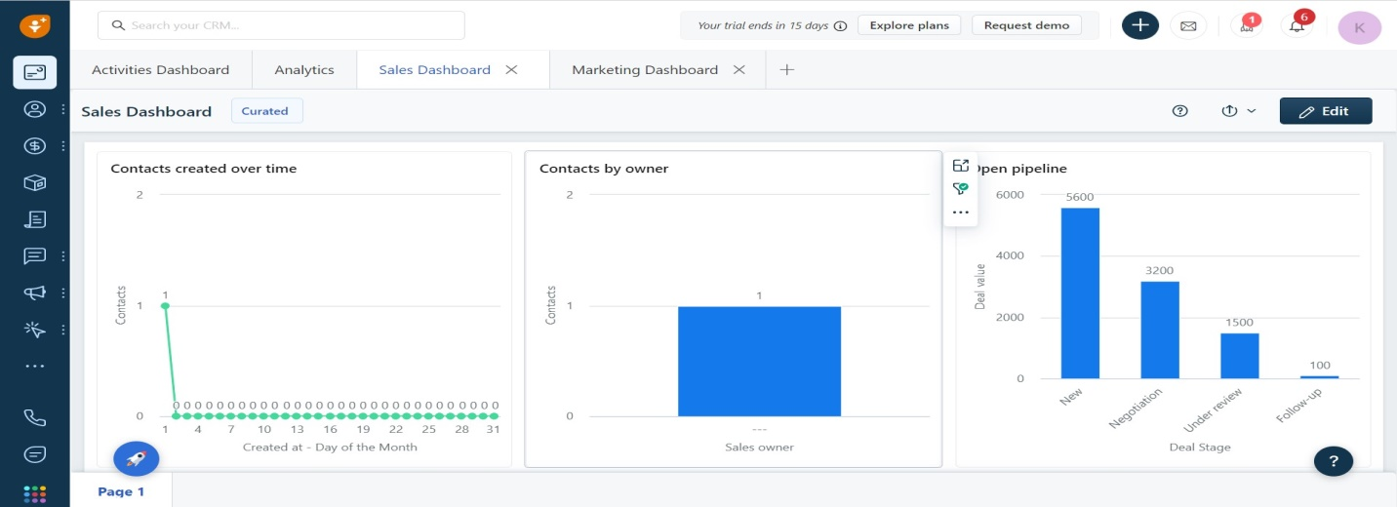

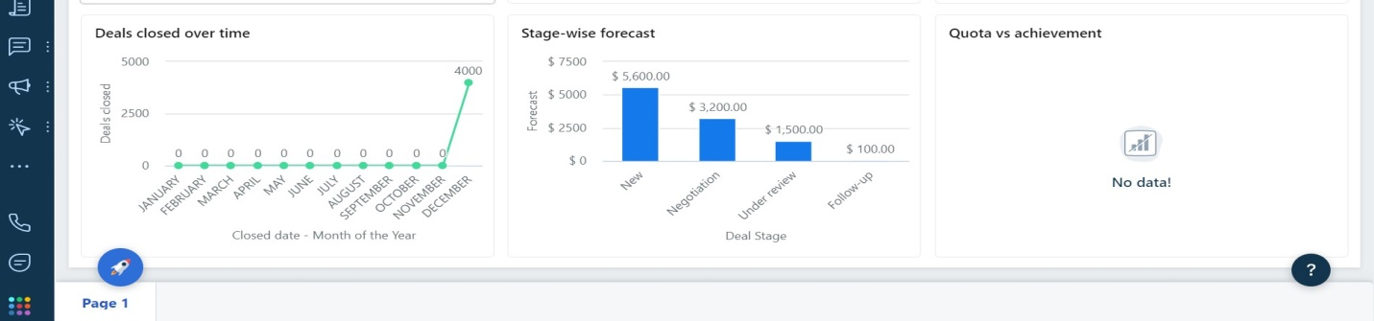

**Marketing dashboard**

In this marketing dashboard, we can see the details of email overview, email engage, email engagement trend, tops link clicked, emails opens by day and emails open by weeks

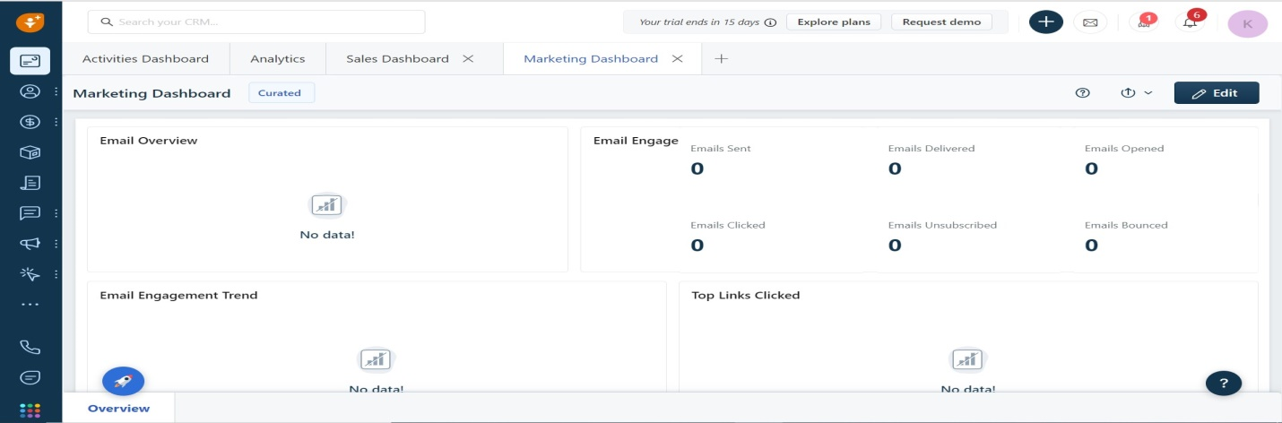

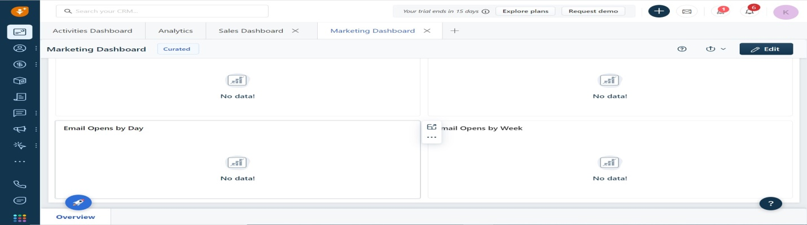

**Overall search bar:**

In this search bar, we can search data using entities and activities…

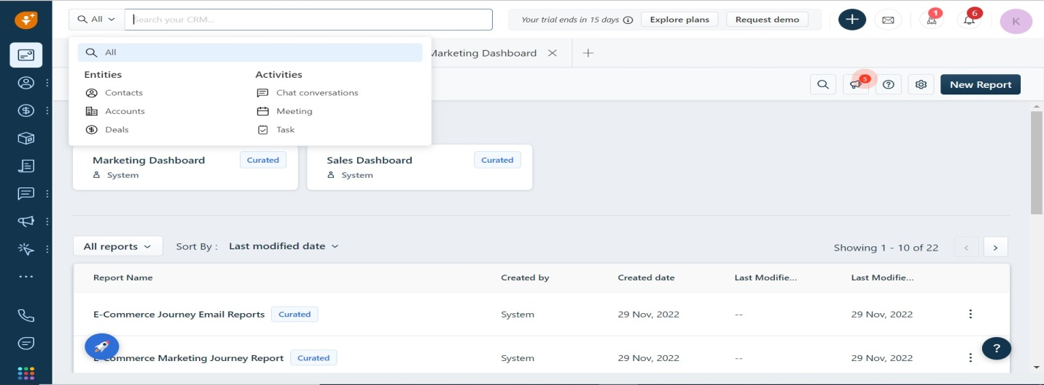

**Add on button:**

## In this button, we can create these functions through this button.

## 

## New Email:

## We can send email through this button. The mail integrated with gmail, Microsoft 365, outlook and others.

## 

## Notification:

## We can see the all notifications here.

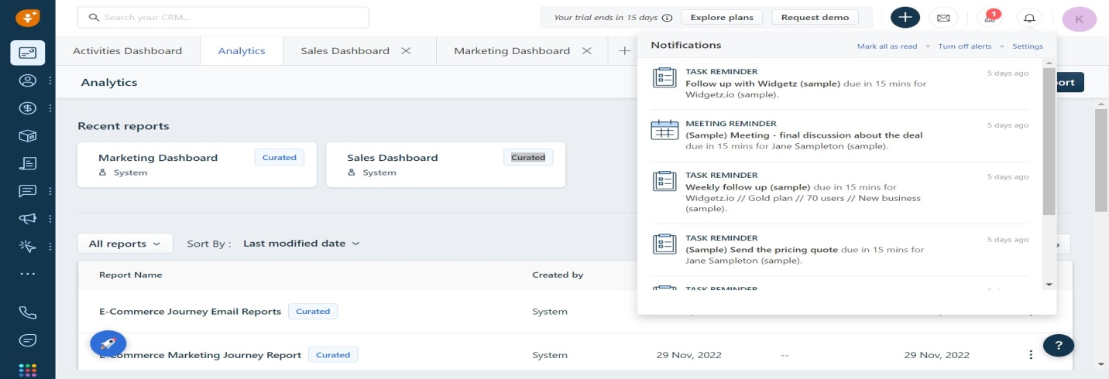

## Contacts and Accounts

## In this above contacts page, we can see the list of the contacts and their status

## 

## In this above contact list, we can make multiple actions like (Mail, Call, Add task, Add note).

|  |  |  |  |  |  |  |  |
| --- | --- | --- | --- | --- | --- | --- | --- |
| Name | Score | Open deals amount | Last contacted | Sales owner | Emails | Works | New activity |
| Name of the contact | Integer – Represents potential of contact | Integer- Represents of deal amount | Integer | String | String | Integer | String |

**Contact details**

## Contact details…

## 

## In this above contact details, we can send a mail to the contact person.

## Mail integrated with: Gmail, Microsoft 360, Outlook

## The navigation menus there, we can access those menus directly.

## 

## Information of contact:

## Basic information :

## Hidden fields :

## Source: Paid search

**List:**

In this list, we can create list, add contact and import contacts…

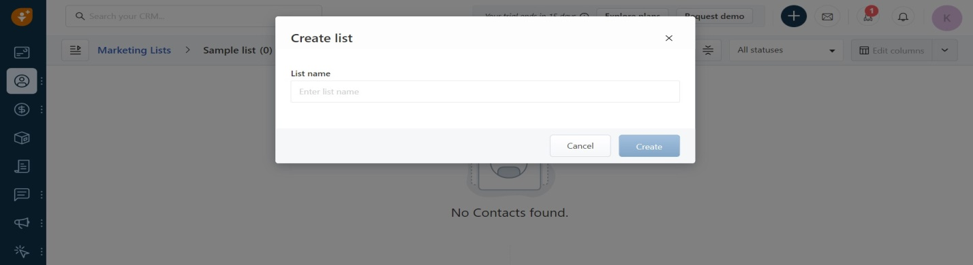

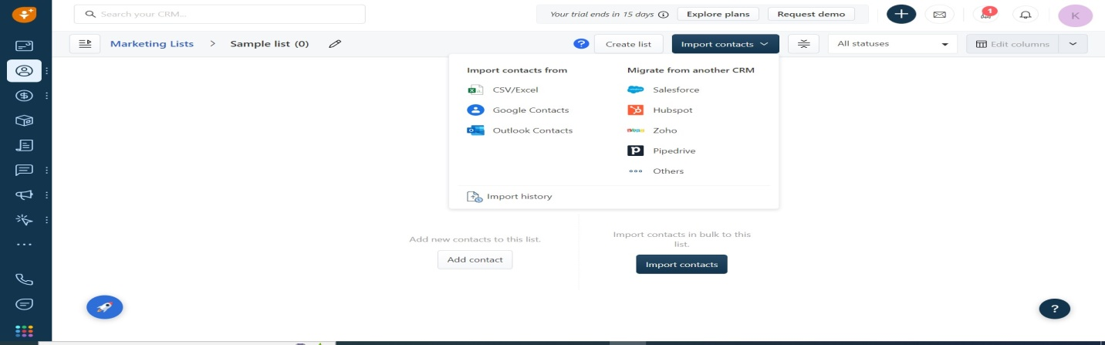

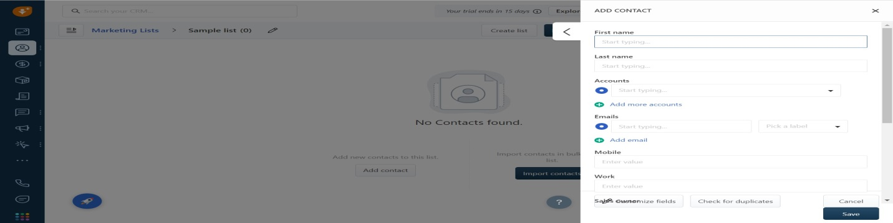

## Accounts:

## In this accounts page, we can see the list of accounts

## 

|  |  |  |  |  |  |  |
| --- | --- | --- | --- | --- | --- | --- |
| Name | Open deals amount | Last contacted time | Related contacted | Sales owner | Website | Phone |
| Account name | Amounts in dollars | Show in days | Respective contact people | Respective sales owner | Gmail or others | Number displays- we can make a call to the respective contact people |

## Edit Account :

## Each account has edit option to edit the account

## 

## In this above edit page, we can edit the (Name of the account, website, phone, sales owner).

## Add account -> Import accounts:

## We can import the a account through csv file

## 

## Kebab edit menu for each account:

## Click on kebab menu, we can access the multiple performance

## 

## In add call log:

## 

## Add meeting:

## Each account has the meeting option, so we can add meeting with desired account.

## 

## Clone Account:

## We can clone the account with other

## 

## Account details:

## We can see the entire details of account

## 

## 

## Deal Management:

## Deals:

## In deals dashboard, we can see the deals and their status. And once our deals are completed in current stage, we can move the deals to the next stage

## Deal filter option:

## To select the respective deals

## 

## Views of deals details:

## When click the particular deals, it shows the full details of the account

## 

|  |  |  |  |  |  |
| --- | --- | --- | --- | --- | --- |
| Industry type | Business type | Annual revenue | Last contacted mode | Deals by deal stage ($5.6k) | Account info |
| Apparel & Accessories | Customer | $1,000,000 | Email Incoming | Won: $4k Follow-up:$100Under review: $1.5k | Acme Inc is a Canada based apparel retailer with 5 physical stores. They also have an e-commerce website |

## Edit the view of deals mode:

## If we want to change the view of deals, we can click the view button to change

## 

## Products:

## In this products page, we can see the list products and add new products.

## 

|  |  |  |  |  |  |
| --- | --- | --- | --- | --- | --- |
| Name | Active | Base currency amount | Category | Created At | Created By |
| Name of the product | Active – it represented active of the product – we can change active of the product | Show in dollars | Respective product category | 3 months ago | Product by |

## Click on particular product, it will show the entire details of products

## 

## Add product:

## If we want to add new product, we can directly click the add button and create product

## 

|  |  |  |  |  |
| --- | --- | --- | --- | --- |
| Name | Category | SKU number | Owner | Valid till |
| Name of the product | ConsumablesHardwareSoftwareMaintenanceSetupTraining | Give stock keeping unit – is a unique code that a seller assigns to every type of item it sells. | Sales owner | Select product validity |

## All categories button:

## Click on all categories button, we can select our desired product to show.

## 

## Product setting:

## Click on setting there is two options: 1. pricing settings 2. Customize product fields

## 

## Pricing setting page:

## Click on pricing setting, it navigates to -> Admin setting -> CPQ settings

## In this above page, we can change the pricing of deals…

## Customize products fields:

## Click on, customize product fields, we can customize the product fields.

## 

## 

## Product edit:

## Click on product edit button, we can edit basic information and system information of product

## Basic Information:

## 

## System information:

## Documents:

## In this document page, we can see the list of document and their details.

## 

|  |  |  |  |
| --- | --- | --- | --- |
| Document Name | Primary contact | Document Stage | Created At |
| Name of the document | Respective contact | Draft – stage of document process | 3 months ago – Created of the document |

## Add account:

## Click on add account, we can add new document on this page.

## 

## Edit document columns:

## Click on edit columns, we can edit the columns to our wish

## 

## Document setting:

## Click on setting, there is three setting option for document

## 1. Manage document templates

## 2. Manage document types

## 3. Customize document fields

## 

## Manage document templates:

## In this page, we can create and edit the document template

## 

## Manage document types:

## In this page, we can add and change the document type

## 

## Customize document fields:

## In this page, we can customize the document and edit basic information and system information

## 

## 

## Document details:

## In this page, we can see the full details of document

## 

## 

## Save and download the document:

## Click on save and download drop-down, we can save pdf to files and download as pdf

## 

## Send to customer:

## Click on send to customer, the selected documents will send to the customer.

## Sales Conversation:

## Inbox:

## Click on inbox, we can see the mail integration with (Gmail, microsoft365, outlook, Zoho and others.

## 

## Connect mail to CRM:

## Click on your desired mail and connect to the CRM

## 

## Bulk email and Email tracking:

## In this inbox page, there is bulk email and email tracking. In bulk email we can see the metrics, bulk email scheduled and bulk email drafts

## 

## In this above page, we have another option email tracking. In this email tracking we can see the opens mail, clicks mail and bounced mail.

## Phone:

## In this phone menu, there are two functions: All phone calls and voicemail

## In all phone calls, we can see the entire call log and add call log. Another option we can directly connected to the freshdesk call center

## 

## Voice mail:

## In this voice mail, we can see the entire voice mail and it can filter by the number

## 

## SMS:

## Click on sms, we can see the entire sms on this page. And we can set up sms with messaging app.

## 

## Sales sequence:

## A sales sequence is a series of steps you can set up to nurture contacts in the CRM. A step can be an email, task, call reminder, email reminder, or SMS. Once your steps are lined up, the CRM executes them automatically for you.

## 

## Marketing Automation:

## Segements

## Target the right contacts by segmenting them first

## 

## Customer journeys:

## Nurture your customers with these ready-to-use journey playbooks… we can enable journey with mail, whatsApp, sms, web chat.

## 

## Journey Emails:

## Create emails for specific moments in customer journeys

## Draft emails that you can automatically send any time in your customer’s journey—like when they return to your website.

## 

## Click on create journey email, we can create journey mail

## 

## Chat bot:

## Build a chatbot with zero coding, integrate it with all your favorite apps, and provide personalized resolutions to your customers in multiple languages without live-agent intervention.

## 

## Click on the use button, we can use that chat bot for service.

## 

## Email campaign:

## Turn email blasts into personalized conversations

## 

## Transactional email:

## Send automated emails on cue for every interaction… We can create transactional email on this page.

## 

## Whatsapp Campaign:

## Marketing campaigns don’t have to be just emails - Send rich WhatsApp messages automatically at every stage of the customer’s journey. We can connect our whatsapp for services.

## 

## Social media campaign:

## Connect your social media accounts to the CRM so you can run your marketing right from here. Add forms to import leads from them, add pages to publish posts without leaving the CRM, and more.

## Once you connect your social media accounts, you can start adding lead gen forms and run campaigns on social media pages right from the CRM.

## 

## 

## SMS Campaign:

## Text your contacts automatically in real time - Create personalized SMS messages that you can quickly invoke the next time you plan your customer’s journey.

## Connect your SMS service provider (Twilio, Gupshup) account to create SMS campaign

## 

## Offline events:

## Bring contacts from offline events into the CRM

## 

## Web analytics and management:

## Forums:

## In this forums page, we can see the list of forums and create new forums.

## 

## Landing pages:

## In landing page, we can create a landing page for our need, we can add column, buttons etc…

## 

## Analytics and chat reports:

## Analytics:

## In this analytics reports page, we can see the list of reports and we have filter option to select specific report.

## 

## Report details:

## Click on report, it will show the entire details of the report. And we can edit, export and save the report.

## 

## Chart reports:

## In this chat reports, we can see the different types of chat method. Each chat method contains list of reports.

## 

## Settings -> Admin settings -> Communication channels

## All settings related to your email, phone, chat and other communication channels

## Email:

## In this Email setting, we have different mail related options

## 

## Incoming Emails

## In this incoming email, we can auto-forward incoming emails to the CRM by copying the default sales email address (see below) and pasting it in your email provider’s settings. Once this is done, you can link emails to the right contacts, and even create new ones if they don’t exist already.

## 

## Domain verification

## To verify domains and manager senders for high deliverability of outgoing

## 

## Team inbox

## Admins can create a common inbox, like contact-us@yourcompany.com, where everyone in the team will have access to all emails so anybody from the team can step in and respond to open conversations.

## 

## Sales email templates

## How do templates make work easier for you?

## • You can use placeholders to create templates that are both personalized and ideal for bulk emailing.

## • These templates save precious time when you’re planning large-scale automated sequences.

## 

## Marketing email configuration

## Customize the logo, sender details and font colors in your marketing. And we can integrate social media apps on this page.

## 

## 

## 

## 

## Phone

## In phone setting, we have multiple phone related services.

## 

## Phone Numbers

## We can buy and manage phone numbers from 90+ countries

## 

## Agent status for call

## Create a custom status to ensure agents choose the most appropriate reason for not being available to attend calls

## 

## Business hours for calls

## Add working hours across time zones for every day of the week

## 

## Call flows

## Set up call queues and messages to connect callers with your team

## 

## Messages and greetings

## Record automated messages and greetings for every business situation

## 

## Chat channels

## In this chat channels, we have multiple chat channels to integrate with your service.

## 

## Chat settings

## In this chat setting, we have multiple chat related settings. It helps to maintain good communication with customer.

## 

## 

## CRM modules and automation

## Find settings for your contacts, accounts, pipelines, sales activities and automation

## 

## Automation

## 

## Configure price quote (CPQ)

## 

## CPQ settings

## In this CPQ setting, we have multiple options to change the product pricing, document module and document template.

## Other setting

## In his other setting, we have multiple options to manage and change the currency, tags, audit log and announcements

## Data import and Migration

## Import your contacts, accounts or just migrate your complete sales data from another CRM

## 

## Migrate from another CRM

## In this migration setting, we can migrate from another CRM

## 

## Website Tracking, Integrations, and APIs

## Integrate your website and all your most-used apps with the CRM

## 

## 

## Users and Permissions

## Manage all your users in the CRM, what they can do, and where they’re allowed to do it

## 

## Manage items in the left navigation bar

## You can show, hide and reorder items in the left nav bar for this role. You can also add, remove and rename groups.

## 

## Manage user

## Add and manage all your users from here. You can assign them a role, specify their contact details and put them in teams.

## 

## Manage Workflow

## In this manage workflow, we can create and edit the workflow

## 

## Manage contact lifecycle stage

## Customize everything about the default lifecycle stages: rename, reorder or disable them. Plus you can add a new stage that reflects your business process, like Evangelist or Marketing Qualified Lead. All statuses within a stage are customizable. If you want contacts to change stages automatically, use the rules at the bottom of this page.

## 

## 

## Manage activities

## Manage common sales activities (like tasks, meetings, emails) from here. You can also create activities that are specific to your business. Once you create activities, your sales reps can start using them via the + button on the top-right of this page.

## 

## 

## Manage custom modules

## Add custom modules that reflect your sales model. These could be real estate properties, invoices, or just about anything else. You can use lookup fields to share data between your custom modules and the default Contacts, Accounts and Deals modules.

## 

## Phone

## To start making calls, buy a phone number.

## Chat

## In this chat section, we can make conversation through web chat.

## 

**Close deals faster by sending the right message at the right time -** Sales and marketing can work together to deliver personalized customer experiences. Understand customer intent and send the right message to close deals faster.

**Reduce IT complexity & cost with a comprehensive solution -** Keep teams happy with a single, all-in-one solution that is affordable, easy to implement, and easier to use. Increase adoption, reduce costs and boost morale.